

Beam Test of Novel ASICs and Sensors

M. Chrząszcz, I. Levy



Abstract

The paper presents tests performed on GaAs sensor prototypes for special calorimeters in the very forward region of detectors at future e⁺e⁻ colliders and for beam condition monitoring at LHC. Sensors have to survive high radiation doses. The measurements described are the first done with sensors assembled with front-end ASICs developed especially for them.
We report of the laboratory tests of a full system including linearity and cross talk measurements for several instrumented channels. The second part of our report contains results of the test beam measurements in Test Beam area 22 of DESY using 4,5GeV electrons.
Preliminary results on the performance of the sensors are also given.

1 Motivation

At high energy collider detectors are needed to fully exploit the physics potential. Detectors are highly complicated devices composited of specialized sub detectors. One of the most precise detectors use silicon crystals as sensors. Silicon offers reliable and fast detectors. Segmented detectors, have been used successfully to precisely image the tracks of charged particles in many experiments. The operation of such devices is affected when they are irradiated with high fluence (above 5 x 10¹⁴ particles/cm²) of neutrons or high-energy hadrons, corresponding to about 5 years of LHC operation at a luminosity of 10³⁴ cm⁻² s⁻¹ for detectors closest to the beam. Radiation-induced defects are introduced into crystal lattice, completely changing its electrical properties. One of the results of such a transition is the loss of charge released by a traveling particle. Damage to the bulk by both charged and neutral particles, however, is difficult to combat. It takes just 25 eV to knock a silicon atom out of its lattice point. This leads to the formation of defects, in some instances involving impurity atoms in the material. Defects can be electrically active, leading to increased space-charge, leakage current and charge trapping. Increased space-charge prevents the electric field from penetrating the material unless high bias voltages are used. Moreover, radiation-induced space-charge can increase after the radiation source is removed, a phenomenon called reverse annealing. It has proven necessary to cool between -10°C and -20°C to reduce the leakage current and reverse annealing. The addition of oxygen into wafers has been found to reduce the space-charge build-up and improve reverse annealing for damage caused by charged particles. The use of multiguard structures, where biased guard rings surround the active detector area, has allowed high-voltage operation at the expense of larger inactive regions at the detector edge. Guard structures are used for achieving long-term stability, to reduce the current in the active area, and to prevent avalanche breakdown when high bias voltage is required.
Prior to irradiation, electrons and holes contribute equally to the signal in the case of detector where both electrodes have the same area. For a detector with a segmented collecting electrode, the larger fraction of the signal is produced by the carrier that travels towards it. This can be derived using a famous theorem of Simon Ramo and William Shockley (Ramo 1939; Shockley 1938).
For CMS a sophisticated Beam and Radiation Monitoring System (BRM) has been developed to monitor the beam halo and to protect the detector. It is clear that near the beam it will be a continuous flux of halo particles, which will cause long term effects, but the most probable and more dangerous scenario is a fast burst of radiation in the detector. This requires the BRM to be sensitive to fast changes of beam parameters.
BRMs consist of several components. One of them is BCM1F, whose task is to measure the beam conditions bunch by bunch. Sensors of this device are made of single-crystal CVD diamonds. This technology enables sufficient time resolution and small size. Four of sCVD sensors are placed on both sides of the IP in a distance of 1,8m each. The position of BCM1F is shown on the figure below.
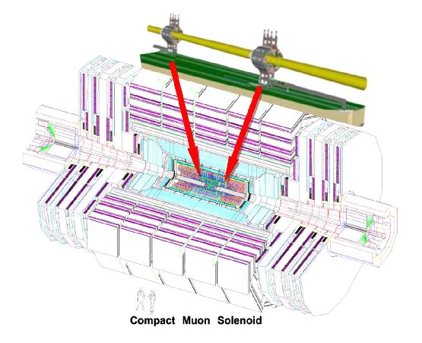
Fig1 : Sketch of the CMS detector with the BCM1F devices.
GaAs is considered to be one of the possible materials sensor layers of LumiCal and BeamCal fot the International Large Detector (ILD), see Fig2.
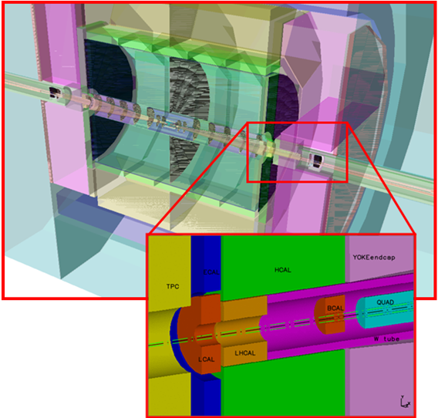
Fig2 : The very forward region of the ILD detector.
BeamCal is built from two half-cylinders with tungsten as an absorber. Each tungsten layer is embedded in a mechanical frame stabilized by steel rods. One layer of tungsten plate, brass ring and sensor are shown on the Fig3.
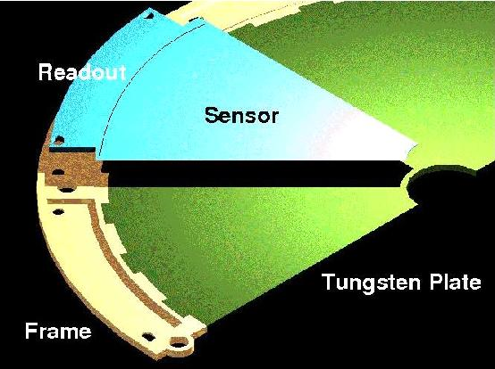
Fig3: Half-layer of an absorber disk assembled with a sensor of BeamCal
Sensors foreseen for the BeamCal are made of two materials: GaAs and CVD diamond in the region closer to the beam pipe. Two kinds of sensors are used due to the fact that CVD diamond is very expensive, but still is more radiation resistant than GaAs.
Fig4: Mechanic structure of LumiCal. Disk made of tungsten are positioned using 4 bolts.

The construction of LumiCal is in principal very similar to the BeamCal. Mechanical precision of this device has to be greater than for BeamCal. Thus the tungsten plates have to mount with a precision of 20µm.

2 Semiconductor detectors

Charged particles traveling inside matter interact with the material mostly through electromagnetic processes. In this process the charged particle looses energy and deposits it inside the material. At low energies this process is governed by ionization and at high energies also radiative losses contribute. At a certain energy the ionization loss becomes minimal – a particle at this energy is called 'minimum ionizing particle' or MIP. The energy loss of particles in matter is well described by the Bethe-Bloch-formula. The amount of charge released in the material is proportional to the energy deposited in the material, as it takes a constant value of energy to create an electron-hole pair (ionization energy). This value is a property of the material (semiconductor), and it depends on its band gap.
In semiconductor materials not all pairs could be measured since they can recombine with the opposite charge (electron / hole) on their way (to the electrodes). This effect depends on the voltage applied and on features of the semiconductor like contamination, regularity of the crystal structure and others. The ratio between the charge produced and the charge collected is called Charge Collection Efficiency (CCE). The Charge Collection Distance – CCD represents the averaged drift distance of an electron and a hole before they are trapped.

3 ASIC

The Application-Specific Integrated Circuit (ASIC) used here with GaAs sensors has to fulfill several technical requirements. It is designed to work in two modes: physics mode and calibration mode (high or low). First mode is used for detecting electromagnetic showers so it has to be sensitive to charges of about 10pC in each channel. Calibration mode is used to pick up signals coming from MIPs. The charge that is induced by a MIP is around 2fC (calculated for a 300µm Si sensor).
Fig5 : Photograph of preamplifier.
The preamplifier is bonded and glued (shown in Fig5). The right four channels are made in an active feedback technology and the left in passive feedback technology. This is represented in the calibration plots in a different slope.
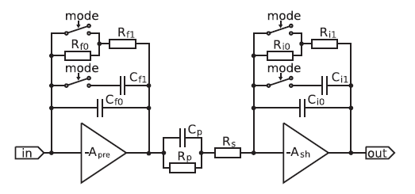
Fig6: Block diagram of single front-end channel.
Each channel has got its own amplifier, as shown in Fig7. Tests were done using high gain mode for the first preamplifier and low gain mode for the shaper, because saturation was observed in high-high configuration mode.

4 Preparation to the test beam

This test beam took place in beam line 22 of DESY II cyclotron ring in Hamburg, with 4.5 GeV electron beam between 29.7.2010 and 12.8.2010. The aims of the test bean were :
- Prove front end electronics operation together with sensor and automated triggered readout in a particle beam.
- Collect experiences for preparation of a BCM1F/BeamCal/LumiCal prototype subset – plane or sector (‘deliverable’ within MC-PAD).
In this part of the paper we will describe the preparation and test beam setup and our part of the work.

4.1 Readout

As the ASICs readout is almost complete, the only instrument that is not implement is the ADC. To digitize the signal in this test beam a CAEN v1721 flash ADC was used. That ADC is already used by our group in the beam diagnosis system in CMS (BCM1F). This ADC can read and store (to a buffer for every one of its 8 channels) the digitized DC level every 2 ns. Once triggered the ADC reads from the buffer all 8 channels. It can record events up to 4 ms long, and it can adjust the position of the readout window with respect to the trigger position. The ADC is connected to a computer via an optical link that allows data transfer rate of 500Mb/s. The ADC is controlled by the computer via the DAQ software.

4.2 Software

An existing DAQ (of BCM1F) was used with small changes in the post analysis. The DAQ first sets the configuration of the ADC and initializes it. Then the DAQ creates a ROOT tree to store all information, each trigger is saved as 8 entries in the file (1 channel = 1 entry in ROOT file). The program consists mainly of an endless loop that writes information after each trigger. In our setting the trigger is always external. When getting a trigger the program read the buffer of all 8 channels processes them and saves them in to the ROOT file. For each event we save the following parameters.
- time_sec - time of trigger in seconds
- time_usec - time of trigger in microseconds
- ACQ_Status
- VME_Status
- channel - number of channel (0-7)
- Event - number of event
- EventHeader1
- EventHeader2
- EventHeader3
- EventHeader4
- BaseMean - Baseline value
- BaseSigma - sigma of base line calculation
- N-Nsamples - number of data points
- data - the array of data for every 2ns
- Sigheight - high of signal from base line
- Sigsize - the integrated signal size
- Hightime - point where pick of signal was

In this form the program already makes some basic analysis on the original data. The measurement of the ADC gives an array of data that contains the number of ADC counts for each 2ns in time from the start till the end of the readout window. Since we need eventually the integrated charge, we first need the integrated voltage.

4.3 Integration method

We are using two ways for integrating data from ADC: one integrates ADC data in the set window from ADC max value, second from the previously calculated base line value. To calculate signals measured by sensor we subtract the pedestal from the signal. In the second method, we calculate first the signal baseline and then sum up the differences between the signal and baseline. This method will give us an absolute integrated number. One problem that needs to be handled is that in this calculation we ignore the uncertainty of the pedestal, so we need to assume that the pedestal uncertainty is equal to the signal uncertainty (both are coming from the electronic noise) and then take it to consideration in the calculation. This method is used to avoid the influence of baseline shifts. The baseline shift could have a couple of explanations such as temperature changes, voltage jump, and dark current in the sensor itself. Since the average signal in our measurements is around 7 ADC counts, movement of one ADC count are critical.

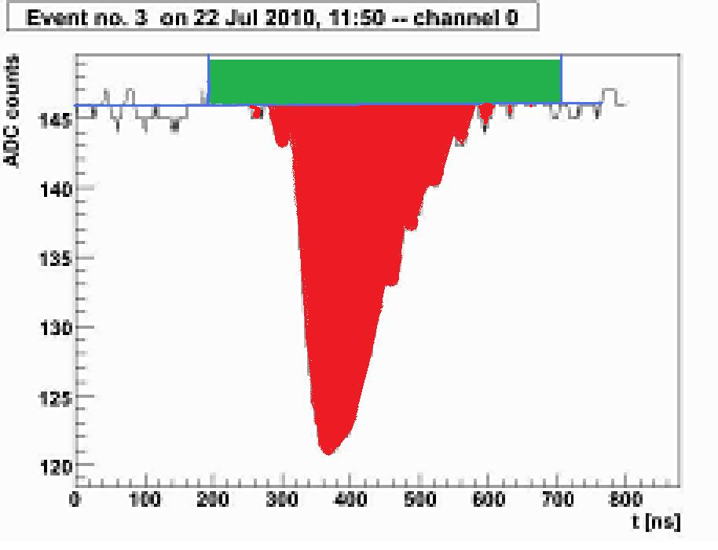
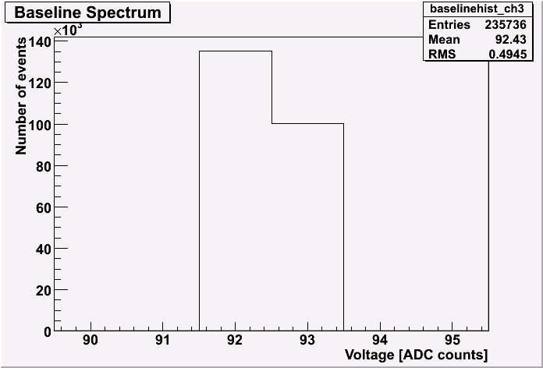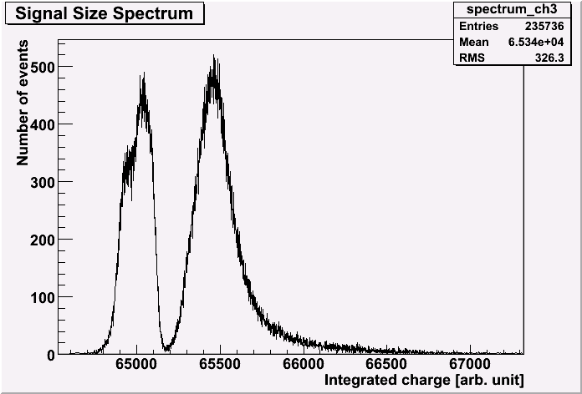
Fig7. A – the signal of one event with the method of integration the first in red and green and second just red. B – Spectra of base line when shifted. C – The effect of thus shift on the signal spectra.

4.4 Calibration

In our measurements we are interested in the amount of charge that is collected in the pad, so we have to calibrate the integrated ADC counts to an amount of charge. To do so we are using the input lines in the board. This lines connect in parallel to the pads to the connection between pad and electronics, it simulate charge collected in pad for the readout electronics. As the resistance of the input lines that, stays constant in time the integrated voltage is in fact charge, we can define this calibration by using the known capacitance of the input capacitors.
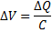 (4.1)
Where ΔV is the voltage step injected, C is the capacitance inside the chip and ΔQ is the charge. To do this calibration, we will use this system: we will generate a negative square pulse white 1Vpp in size, and a TTL trigger signal simultaneity. The pulse inject through an attenuator (1-110dB) to 4 of the 8 simultaneously connected channels in the sensor (to the even or to the odd). The capacitors in the input line in front of the chips have a value of 0.5pF with an uncertainty of ~10%. The trigger signal is going through a dual timer for delay to the external trigger entrenches of the ADC. Then we can calculate the amount of charge that is injected as a function of the attenuation that applied:
(4.2)
We repeated this measurement for different attenuation and fitted to get the calibration for each pad. Linearity of the amplification was also checked in the same time.

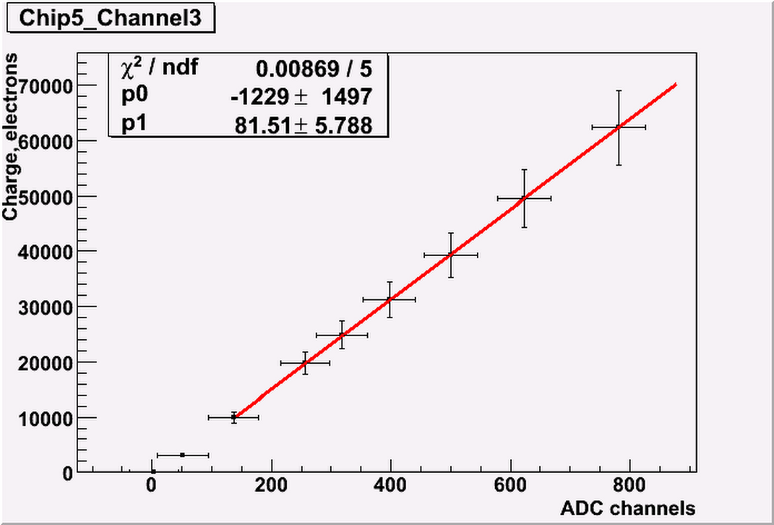
Fig8. A linear calibration plot from ADC counts to number of electrons.

4.5 Cross Talk

During the calibration measurements we noticed a small signal in the channel that was not connected to the input. This small signal called a cross talk signal, and it is the influence of signal in one channel to the neighbor channel. This behavior need to be estimate and measure since it will have an effect on the performance of the sensor.
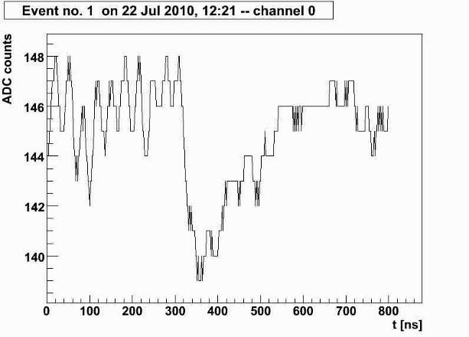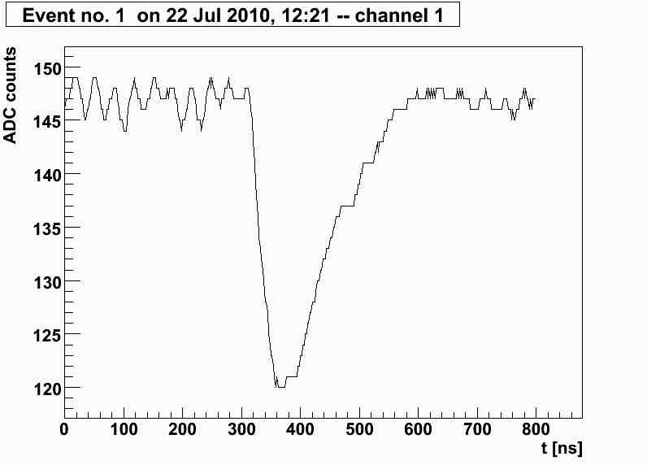
Fig9. A – a real test pulse signal. B – a cross talk signal in the neighbor channel.
We measure this cross talk signal by taking 2 measurement one with injection of input signal going to the even channels and the second for the odd channels. Then we can take for each channel the ratio between the real signal and the cross talk signal in that line. The high value that we get from measurements (around 10% - 20%) is not consistence with the calculations and simulations made for the readout ASICs. A suggestion that this higher value is due to the simulations 4 channels feeding was cheeked after the test beam. Instead of the 4 channels injection, other entrance to for only one channel was made.

5 Test Beam Setting and Measurement

5.1 Beam Generation

A bremsstrahlung beam is generated by a carbon fiber in the circulating beam of the electron/positron synchrotron DESY II. The photons are converted to electron/positron pairs with a metal plate (converter). Then the beam is spread out into a horizontal fan with a dipole magnet. Like a slice, the final beam is cut out of this fan with a collimator.
Therefore, the physics is simple. The bremsstrahlung spectrum has a 1/E dependence. The energy distribution of the electron/positron pair is nearly flat, the geometry is fixed by the beam pipe and setting the magnet current chooses the beam momentum.

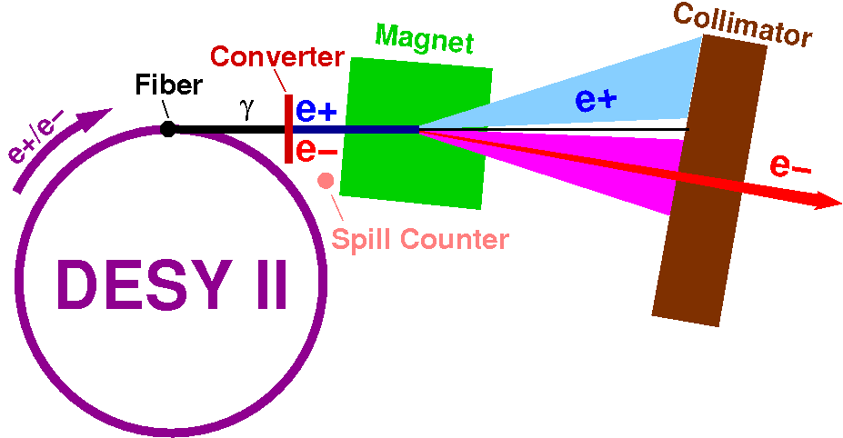
Fig 10. A schematic of the beam generation

5.2 The Telescope

The beam telescope depicted in test beam are 22 was originally assembled by Uli Koetz for the beam tests of the ZEUS MVD. The beam telescope consists of three reference detector modules (Ref.det 1, 2 and 3). Each of them provides three space coordinates (x, y and z) for a track through the telescope. The modules are a version of a CERN development. They consist of two 300 mm thick single-sided silicon sensors of 32mm x 32mm size with a strip pitch of 25 um and a readout pitch of 50 mm; the strip directions of the two sensors in a module are perpendicular to each other. The 640 readout strips on each sensor are readout by the VA2 chips (VA2 chip product of IDE AS, Norway). All modules have a very good signal-to-noise (S/N) ratio for MIP, 80 < S=N < 130, (at least in theory) and a high intrinsic position resolution, 28 mm, as reported by Zeus. The device under test (DUT) and the telescope modules are mounted on a common optical bench. All modules can be shifted in z along the optical bench. A coincidence of three of the four scintillator fingers located at both ends of the optical bench is used to generate a trigger. The whole telescope including trigger is located onto an optical bench. This bench is again mounted on a huge translation stage. The whole system is supposed to be aligned to the beam. .
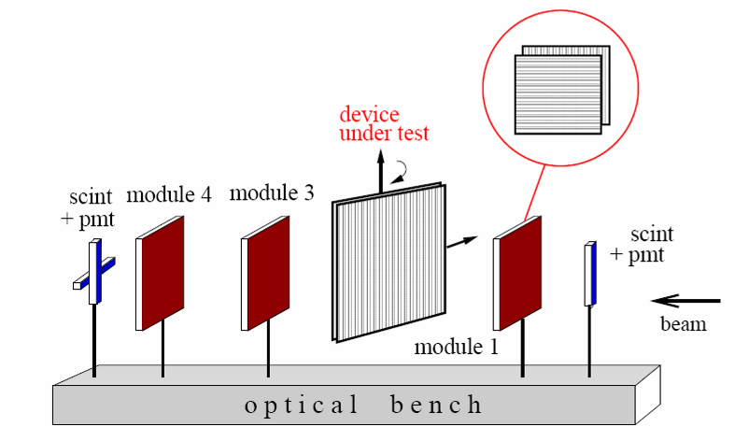
Fig 11. The ZUSE Telescope

5.3 Test Beam Setup

Our detector is placed on a remote-controlled X/Y table that can move sensor box and centered each pad in the beam. The table is placed between the second and third plane of the telescope, this way we can calculate the trajectory of electron crossing the plane detector.
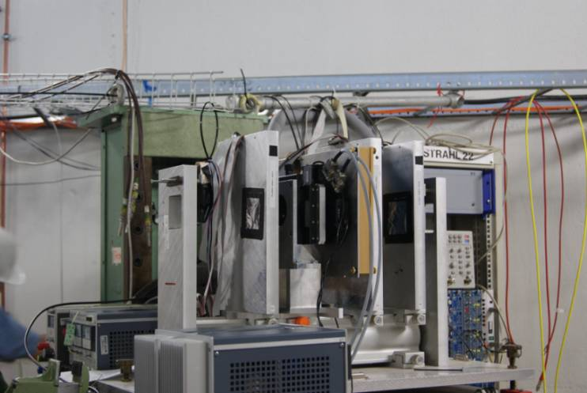
Picture 1. The box sensor broad mount on the x/y table between the telescope plains
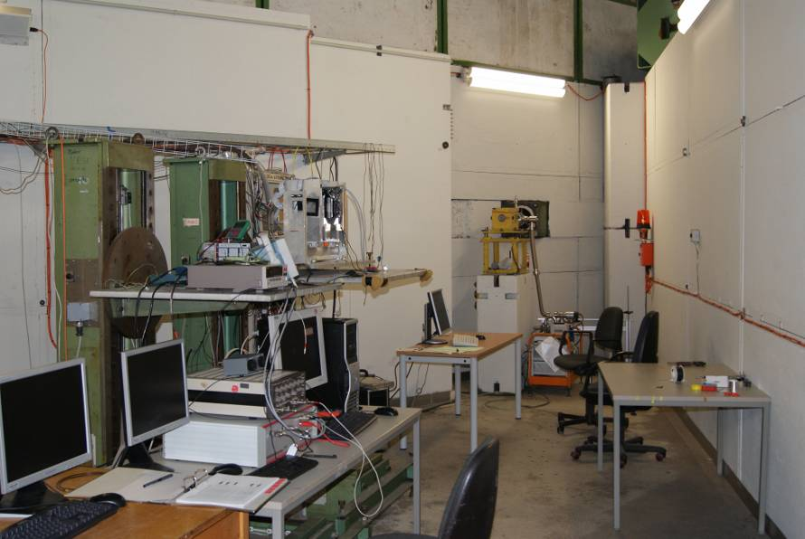
Picture 2. The test beam area (DESY 22)
Three finger scintillators generate in coincidence trigger for the telescope. As the read out time for telescope ~ 1ms and for DAQ ~ 1 µs veto is needed.
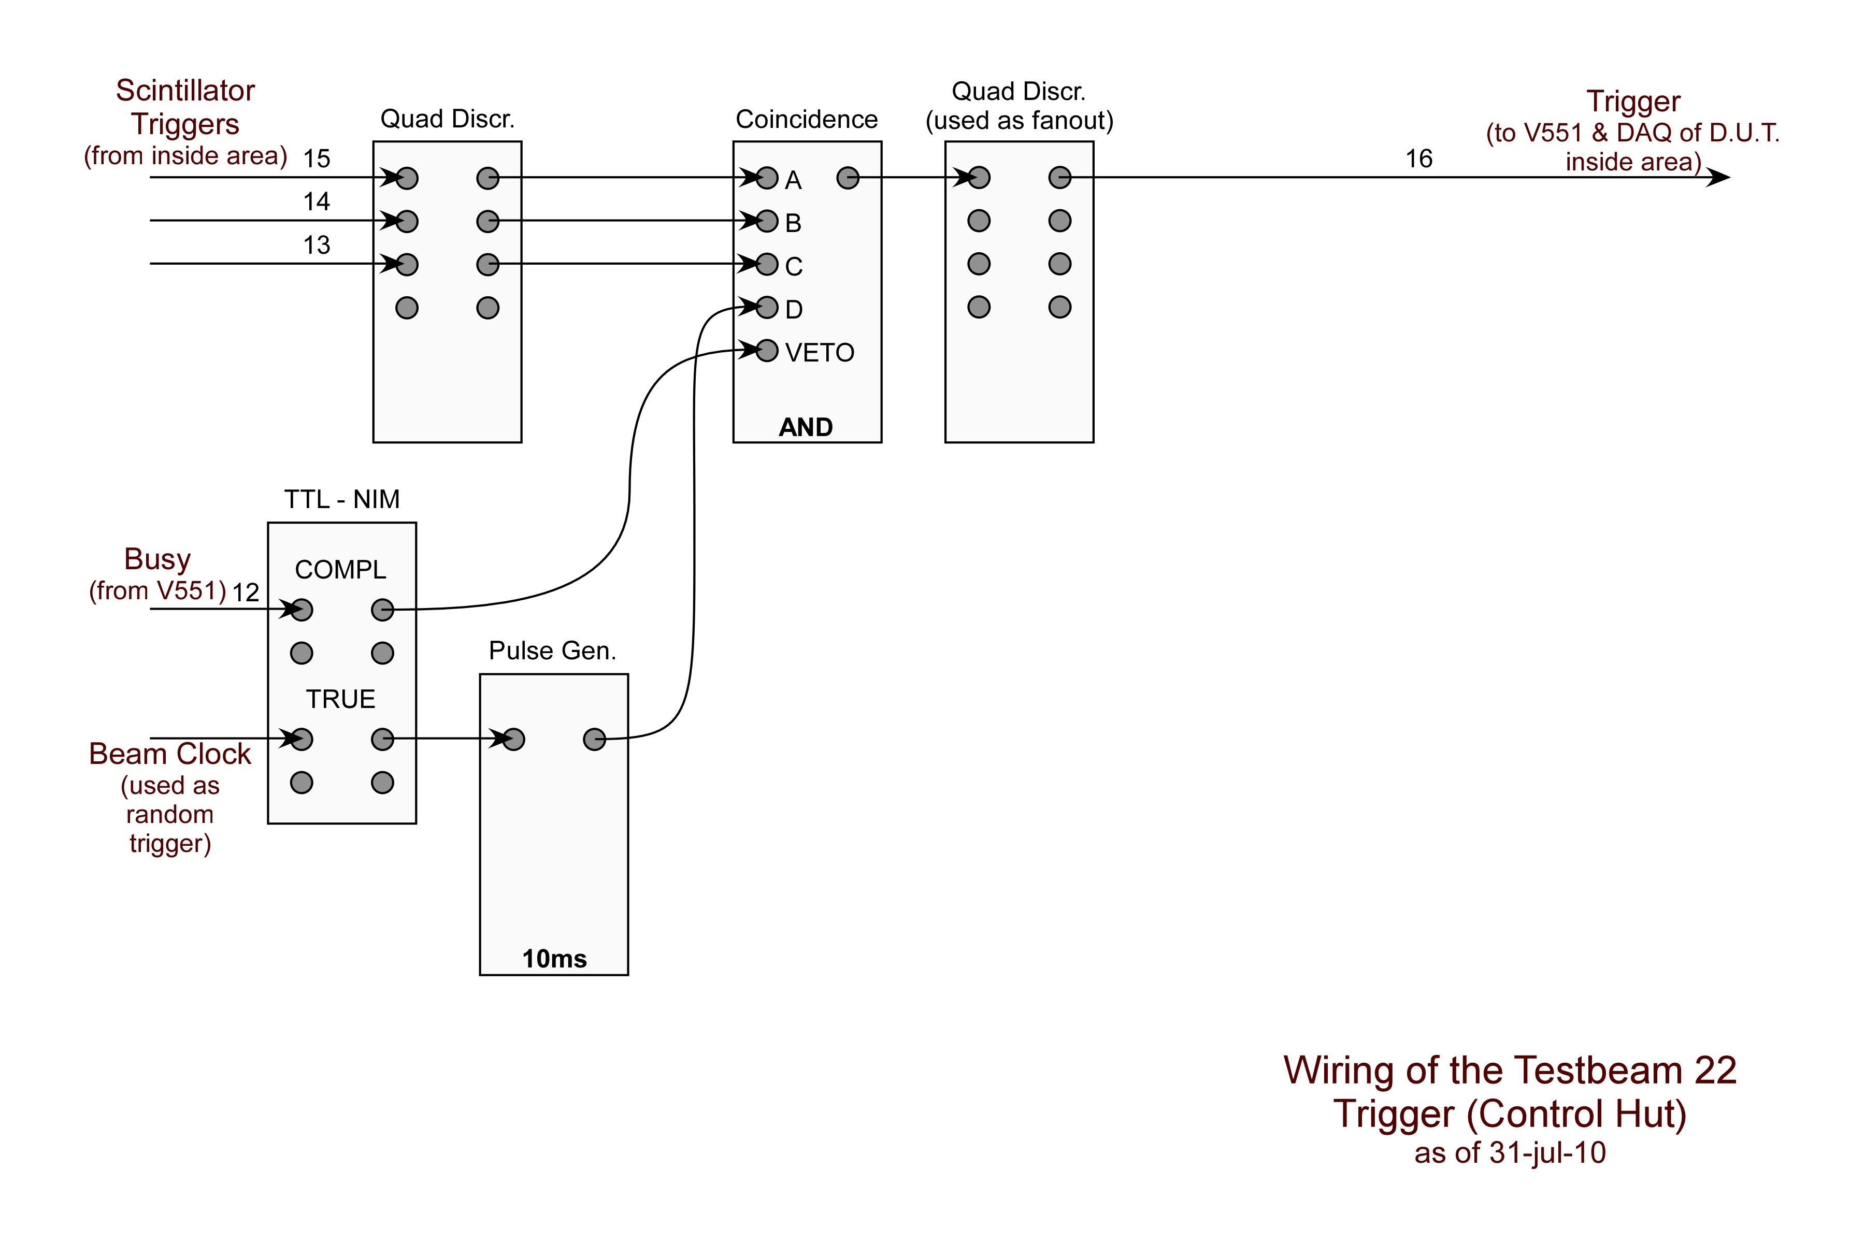
Fig 12 . The veto and trigger schematics of electronics and logical units

5.4 Measurements

It was planned to investigate 4 different regions of the sensor. In the end we investigated only 2 group of 8 pads with connected surrounded pads. Another group was used only for the cross talk measurements. During the test beam next measurements were done with GaAs sensor plane:
- Irradiation of all pads with statistics ~200K events (with Telescope).
- Irradiation of edges between pads (edges between 4 and 3 pads) statistics ~ 2M events each (with Telescope)
- Irradiation of pads connected in chip in order to measure cross talk in unconnected neighboring channels.
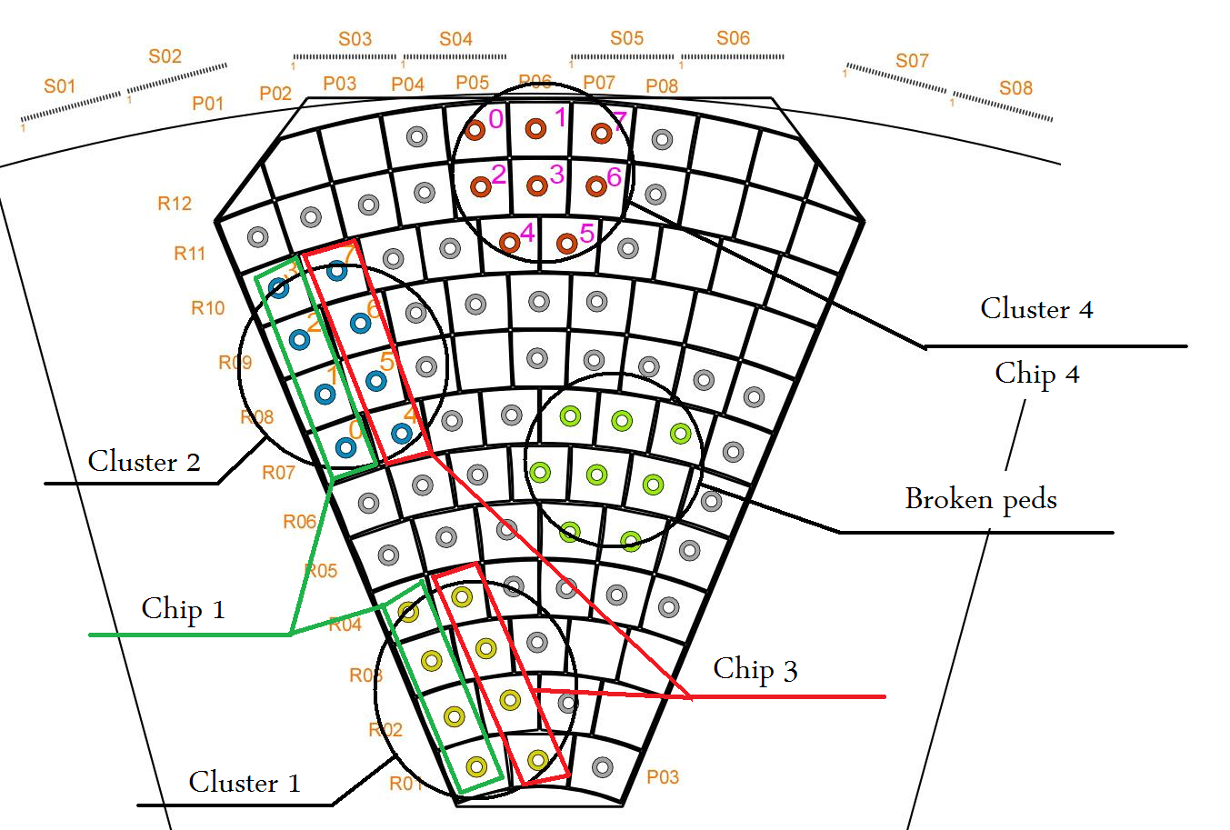
Fig 13. Sketch of the sensor with marked chips and clusters

5.5 CCE calculation

One can expect that the measurement output will be theoretical described by a Gaussian distribution for the pedestal and a Landau distribution from the energy deposition of charge particles in meter for the signal. This description is not entirely correct as the Gaussian distribution for the pedestal is due the random distribution noise from the electronics, this noise will expand each of the single values in the Landau distribution and will give us a Landau Gauss convolution in the signal part of the spectrum. We use the next formula to fit collected spectra (5.1).
(5.1)

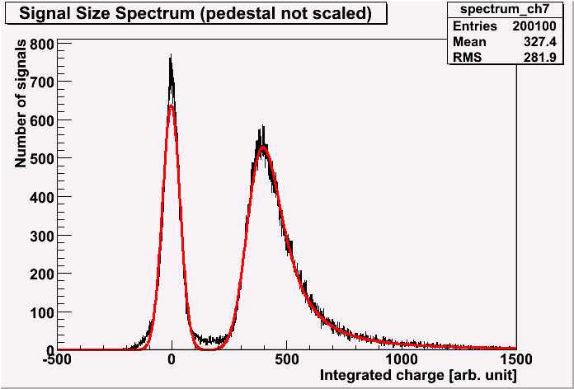
Fig 14. A full spectrum described by a Gaussian distribution for the pedestal and Landau Gauss convolution in the signal part
To fit the spectrum, we use our modified script “realSpectra2.C”. It reads all the input ROOT files, and for the channel selected it organizes the spectra in a proper way (one bin for each integrated ADC count) to one histogram. Prior to fitting process, the script uses the histogram mean value and RMS value to divide the spectrum in two parts the first one it will fit a Gaussian distribution and to the second one it will fit a simple Landau distribution. In the second phase the script will use the first fitting results as starting parameters to the complete fit.
From the fitting parameters that we get, one can calculate several characteristics of the sensor. First signal to noise ratio is calculated by taking the integrated charge and dividing it by the sigma of the pedestal (in the same units). One can also calculate the Charge Collection Efficiency or the Charge Collection Distance that is a characteristic of the Efficiency of the sensor. The CCE is calculated by the next formula (5.2) when Qcollected is the amount of charge calculated from the distance between MPV of signal and mean of pedestal. Qinduced is the property of the GaAs for the amount of charge produced for 100 μm ( = 14687) multiply by thickness of sensor plain in μm (dsen = 500 μm).
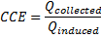 (5.2)

6 Results

6.1 Calibration
We will only put here the results of linear fit for the calibration and not all data collected. In the next tables we will present the parameters from the calibration linear fits for each chip (as described in fig 13). The value of p0 is in Number of Electrons and the value of p1 is in Number of Electron divided to ADC counts.

Calibration chip 1:

Calibration chip 3:

Calibration chip 5

6.2 Fitting result
In the next tables we will present the parameters from the fitting of formula 5.2 to the spectra of each measured pad, the pads divided by cluster as shown in fig 13 . parameters p[0]-p[2] and p[4],p[5] are in units of integrated ADC counts, p[3] is dimensionless and p[6] the normalization that is in number of event.

Cluster 4

Cluster 2

We can see several things in these tables:
- The ratio between the number of event in each pick (p[3]) is expected to be similar to the ratio between the pad area and trigger area 1 - 25mm^2 /49mm^2. But the numbers we get are smaller. That rise the possibility that the pad collect charge from an area bigger then its on area.
- We can see that the norm factor is smaller then 200K that is the number of events for pad. This missing event may appear in fig 14 in 3 area around the pedestal pick, this may by a cross talk signal inside the pedestal.

6.3 Measurements results
In the next tables we will present the preliminary results of calculations made on the measurements.

Cluster 4

Cluster 2

From an uncertainty estimation that we did we can say that the CCE values have an uncertainty of ~10% of there value (30% ± 3%). For channel 6 in cluster 2 the values are need more work since the fit was not good.

6.4 Cross talk
In the next tables we will present the result of cross talk measurements before (of chip 3) and after (chip 1) the test beam.

First measurement for chip 3

Second measurement for chip 3

Cross talk measurements for chip 1 after test beam with 4 input channels in comparison with to 1 input channel.

Here we can compare only the odd channel since the input channel was channel 0.

7 Summary

During the 2 weeks of test beam in the DESY 2 cyclotron at Hamburg we had collected more than 5M events of DAQ, telescope and temperature data. Before and during that time we participated in the preparation and data taking of the test beam.
In the period after the test beam we helped in the data analysis process and achieved same preliminary results that characterize the measured GaAs sensor. From this preliminary results we can say that there is a possibility that pads can collect charge from an area bigger then it size, we also can point out that cross talk signals are appearing in the spectra. This issues need same more attenuation as the lab result of that aspect was not conclusive. In all of our calculations the govern uncertainty was of the input capacitors, an exact values for this capacitors will improve the result show here.

„R&D for Very forward Calorimeters for ILC Detectors” H. Abramowicz et al.
Measurements Performed on GaAs -A possible sensor material for the Forward Region of the ILC- http://www-zeuthen.desy.de/students/2006/doc/iftach.pdf
M.Idzik, Sz.Kulis, D.Przyborowski, „Development of front-end elektronic for the luminosity detektor AT ILC”
http://adweb.desy.de/~testbeam
http://adweb.desy.de/~testbeam
http://www.ifh.de/~chgrah/diamondproperties.html

